# Collatz Conjecture

Big things come in small packages. From tiny acorns grow mighty oaks. Never judge a book by its cover. These familiar euphemisms try to capture, in a pithy way, the basic idea that simple looking systems can often hide a surprising amount of complexity. This basic observations couldn’t more true than in the case of the Collatz Conjecture.

The Collatz Conjecture is so simple that, on the face of it, it must be easy to prove. But like other easily stated suppositions in mathematics, the proof, if one exists, must be particularly difficult to construct, since it has eluded mathematicians for nearly 100 years.

In a nutshell, the [Collatz Conjecture](https://en.wikipedia.org/wiki/Collatz_conjecture) says that a particular process, described just below, when repeatedly applied to any integer always ends up the same way, regardless of the starting value of the integer. The process, referred to as the **Half or Triple-Plus-One** (HTPO) process, is as follows:

<Half or Triple-Plus-One Process

* If the integer is even, divide it by 2
* If the integer is odd, multiply it by 3 and then add 1>

There it is. It is so simple that it can be implemented in a few lines in just about any language; probably even in COBOL. And yet, proving that this conjecture is actually so hard that the famous mathematician Paul Erdös is credited with saying

< Mathematics may not be ready for such problems. – Paul Erdös about the Collatz Conjecture>

Obviously this column is not going to present a proof but it is going to explore some of the properties of the conjecture – including a few that may not have been seen in the literature. There are two reasons for doing so.

The first reason is the sheer joy and delight that arises from seeing inexplicable complexity arise out of such simple rules. Amazingly rich plots results simply by looking at the data from numerical experiments in a variety of different ways. What, at first, may look like randomness resolves itself in patterns later on as the number of integers examined is increased.

The second reason is less about mathematics and far more about human reason. Why a proof is hard to find is a topic in epistemology worth exploring all on its own. Consider that the Collatz conjecture is a system that is far easier to encode in a computer than say the solution to an orbital mechanics problem or the motion of a fluid over a fixed object like an airplane wing. No calculus or linear algebra is required. Nowhere does one need real or complex numbers. All the machinery that is needed is learned in elementary school and yet the proof is much harder than those associated with the ‘more advanced’ topics. Surely there is a Socratic lesson buried in all of this. But before we explore that topic, let’s look at the Collatz conjecture in detail.

Pick an integer, say $$n = 3$$, and apply the HTPO process to it. Since 3 is odd, the resulting value is 10. Now use 10 and the next value and again apply the HTPO process. Since 10 is even, the resulting value is 5. Starting from here and applying in succession leads to the following ‘trajectory’

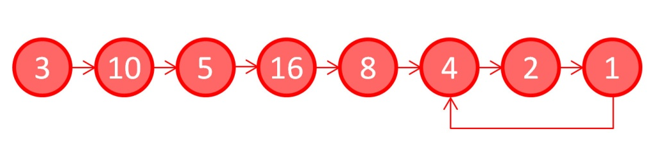

Note how the sequence of numbers rises and falls getting up as high as 16 and falling as low as 1. This is called a hailstone sequence since it is reminiscent of the multiple rises and falls of a hailstone during a thunderstorm. Also note that once the number 1 is reached the sequence is now trapped in the infinitely-repeating ‘4-2-1’ loop. It is customary to stop the iterations when 1 is reached for the first time and to declare that the sequence has stopped. By convention, the number of integers in the sequence (including the starting value) is declared as the stopping time. Thus the stopping time for a starting value of 3 is 8, the number of unique circles in the figure.

The Collatz Conjecture is then the statement that the number 1 is always reached no matter what the initial value may be. While the proof of this assertion has not be obtained, huge numbers have been tested (260 = 1,152,921,504,606,846,976 ) and none have failed to reach 1 and settle into the ‘4-2-1’ loop.

Investigators, looking for a proof, have employed a number of tools in an attempt to better understand what makes this conjecture so shy in being characterized with a logical proof. Many of these tools are visualizations of the stopping times as a function of initial value.

The following figure is one such plot showing the stopping times for the first 100 integers.

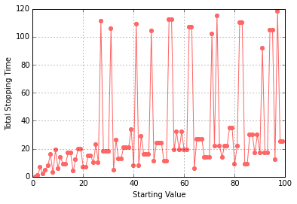

It is remarkable that there is no smooth pattern in the results. Adjacent integers, such as 26 and 27, can have wildly different stopping lengths, 10 versus 111, respectively, while adjacent pairs can have identical stopping lengths. Particularly noteworthy is the fact that the integers 28, 29, and 30 all have a stopping length of 18 despite their rather different trajectories:

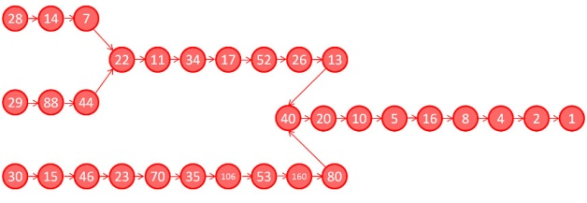

The jerky or random character of the stopping length plot for the first 100 integers transitions into something more akin to patterns within patterns when the number of integers surveyed increases to 2000.

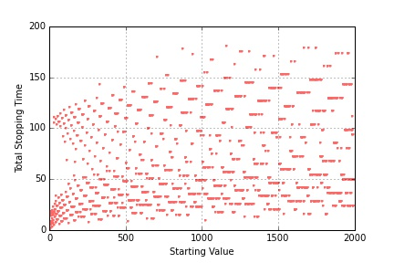

There seem to be overlapping curves asymptotically rising and falling, layered one on top of the other with large regions where they interleave.

Different visualizations reveal different structures. For example, the stopping times for the first 10000 integers, plotted on a semilog plot

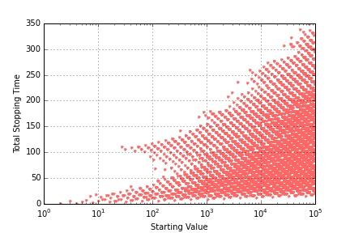

reveal a general triangular shape, whereas the same data shown on a full log-log plot shows

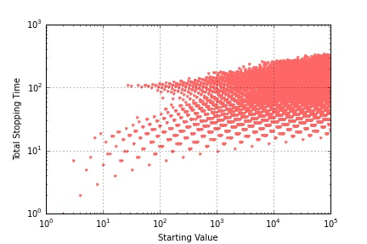

that the values are tending to cluster rather that moving in a unbounded fashion.

This latter observation opened another line of inquiry centered on just how high does the hailstone trajectory go rather than how long does it take for it to land. A little bit of additional coding to capture the full trajectory for the first 2000 integers reveals that one value, 9232, tends to be hit more often than all the others.

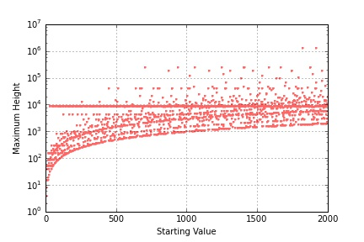

There is a strong line visible just under 104 on the plot and some simple statistics show that 9232 forms 16% of all the highest values in the first 100 integers and about 33.8% for the first 2000. As the integer range increases to 20000, additional horizontal attractors (to coin a term in relation to the Collatz Conjecture) come in, although it is difficult to pick out just how prominent they are due to the business of the plot.

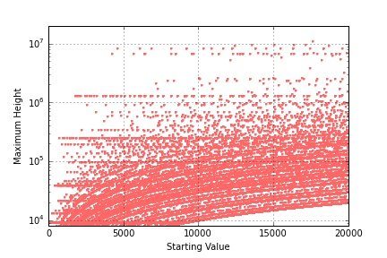

It is interesting to see just how low these horizontal attractors extend.

As this column closes, it is worth repeating that all of this structure comes from a repeated application of the HTPO process for a finite number of times. The fact that mathematics can’t say whether the process will stop for arbitrary integers is astonishing and speaks to many of the basic complexities that arise in proof and logic when the repeated operations are involved. It seems that if Socrates were alive and playing with the Collatz Conjecture he might be inclined to point out that the only wisdom is knowing that we don’t know very much.

## Virtual Economics

I’m not sure if the academic economists pay attention to the start of football season but they should. I’m also not sure that they play videogames, particularly MMORPG, but they should as well. The reason for these recommendations is not that the practitioners of the dismal science need some fun. I am sure that they do but that’s beside the point. No, my recommendations stem from the fact these both of these pastimes occupy a huge amount of people time and wherever there is people time involved economics is close behind.

Consider, for example, that at the beginning of each football season, there is a wonderful and voluntary establishment of a huge host of microeconomies on a scale nomies roeconomies antion to the a scale undreamt of by Adam Smith or Milton Friedman. Of course I am talking about the establishment hundreds of thousands or, perhaps, millions of fantasy football leagues usually filled with anywhere from 8 to 16 teams, most bearing creative or absurd names.

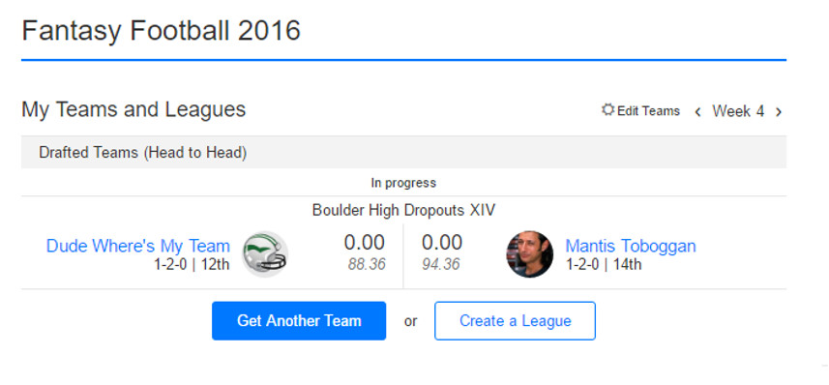

For those who don’t know, the owner/manager of a fantasy football team selects players from the existing rosters of the 32 teams that comprise the National Football League. The standard recipe is that the points a player earns during a game are credited to the fantasy football owner’s team. In addition, the players also earn their fantasy team points for performance milestones such as 0.1 points for every 10 yards rushing or every 10 yards receiving, although this later advancement was only widely adopted once fantasy football moved from newspaper box scores to the internet (yes, sadly, I am that old and I have been playing fantasy football for over 25 years). To be complete, the concept of player requires some clarification. To simulate the importance of the defense and special teams (punt and kickoff returns), the idea of a ‘player’ is extended to include an entire team’s defensive and kick return units. Point come from touchdowns scored on kick returns and defensive scores (pick six, safeties, etc.) and from performance milestones such as interceptions, fumbles recovered, and points allowed (lower being better).

A possible team configuration might be (and unfortunately is)

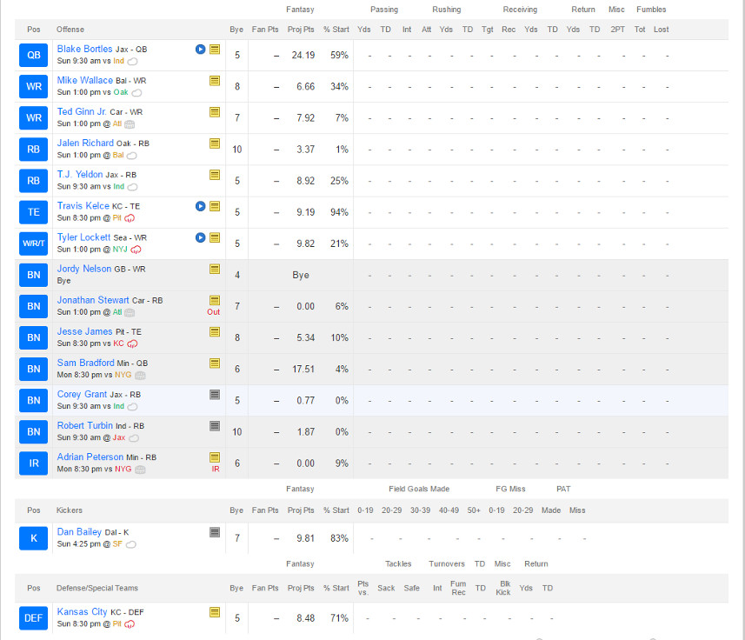

Team owners draft based on a pre-determined order that usually snakes forward and back every other round so that an owner with a low pick in one round has a high pick in the next round and so on. Players are the exclusive property of the team to which they belong and every owner must fill out a roster that has representation in the key skill areas: quarterback, running back, wide receiver, tight end, place kicker, and defense/special teams.

And so we arrive at the first set of the many economic lessons provided by fantasy football: the ideas of scarcity, constraints, and substitution. As the number of teams in a league increases the ability of each team to have more than one or two exceptional players decreases. Owners are forced to fill in required positions with players that aren’t top of the line. There is simply no way to stack a team with only quarterbacks or placekickers (generally the two highest scoring positions). In addition, owners must find credible backups to handle the bye weeks where some teams don’t play and to mitigate the possibility of a serious or even season-ending injury (yes [Adrian Peterson](http://www.usatoday.com/story/sports/nfl/vikings/2016/09/24/adrian-peterson-targets-rapid-return/91044554/) and [Danny Woodhead](http://www.espn.com/nfl/story/_/page/Mike-McCoy/danny-woodhead-san-diego-chargers-torn-acl-right-knee) I am lamenting your loss).

The next lesson centers on the concept of [comparative advantage](http://commoncents.blogwyrm.com/?p=27). The different skill positions have very different drop offs in terms of points. The top of the line quarterbacks (e.g. Tom Brady or Drew Brees) may earn 25 points/week but the drop in points is such that the 16th quarterback may earn only 30% fewer points (18 points/week). The top running backs may only earn 19 points/week but the drop is steeper at nearly 37% fewer points (12 points/week). Since an owner must field two running backs and good running backs are harder to find, there is a comparative advantage to taking running backs before quarterbacks, even though the quarterback position scores more points. If an owner gets two top-flight running backs and one mid-tier quarterback he stands to earn 56 points/week compared with 49 points/week with a star quarterback and mid-tier running backs. Taking into account the relative scarcity of running backs, makes the analysis swing more heavily towards drafting them above passers.

Another very useful lesson driven home by fantasy football is the notion of [opportunity cost](https://en.wikipedia.org/wiki/Opportunity_cost). Generally, it will turn out that an owner will have a glut of good players in one position, say receiver, and a dearth in another, say running back (again my heart aches over Adrian Peterson) or quarterback. The smart owner will no doubt wish to trade from his surplus to fill his lack. Sometimes this will result in what, on the surface, looks like an inequitable trade. Issac M. Morehouse details in a [fun and very readable post a story of how a trade that was beneficial to him was vetoed by the commissioner of his league](https://fee.org/articles/fantasy-football-opportunity-cost-and-comparative-advantage/) because the later judge it to be unfair. Morehouse was willing to give a 25 point/week-player from his roster in exchange for a 15 point/week-player in order to fill a gap. The fact that the point total seemed lopsided (giving up 25 points/week for 15 points/week) didn’t take into account the opportunity cost that Morehouse would suffer by not being able to field an entire roster.

Okay, I’ve obviously made a case for fantasy football being a tool to teach economics but what can academic economists – the guys who teach this stuff at the university level – hope to learn? Well, the short answer is that all of these fantasy football leagues are as close to an ensemble of repeatable experiments as economists are ever likely to get. Each league of similar type is one trial in a huge self-organizing experiment where the participants want to win and strive against each other and the economic realities to do so. The fact that the size of a given league is small is offset by the great number of copies that exist. I don’t know if professional economists are studying fantasy football but I do know that it has been bandied about.

And if sports isn’t their thing there are tons of choices from the realm of videogames. In particular MMORPGs, which typically have high incentives built in that reward time played with levels, achievements, and the like, are especially attractive. And since the players are in the real world, even if their imaginations are in cyberspace, and they spend real time (and sometimes real money) commodities in the virtual space often become real commodities.

During the Warcraft craze 5-10 years back, one could but high level characters on eBay. Specialized merchants cropped up who offered to either deliver a high-level character directly to the customer or take a customer’s existing character and level it up. These services were exchanged for payment in real-world dollars, which reflected the time and skill of the leveler.

Even the so-called casual gamer can engage in virtual economies of differing complexities. Members of my own family are partial to Neopets and the various mixes of capitalism and socialism that can be found within that universe.

Regardless of the form a pastime takes or the venue in which it is embodied, real time is spent by real people, who, maybe without even knowing it, are forming lots of microeconomies that can teach us all some big lessons.

# New Universe – Part 3: The Long Runs and the Pitt/Draft/War

In this piece, the 3-month-long look at the Marvel experiment called the *New Universe* comes to a close. The previous two articles discussed the [overall original concept](http://aboutcomics.blogwyrm.com/?p=907) and the [short-lived series](http://aboutcomics.blogwyrm.com/?p=955) that were repurposed halfway through their run to provide the supporting material for the series that survived. This article will examine the series that made it to the end (*D.P. 7*, *Jvstice*, *Psi Force*, and *Star Brand*) and the corresponding limited series (*The Pitt*, *The Draft*, and *The War*) that were used to create the backdrop of world war and paranormal involvement in the conflict.

As a result of the ‘editorial renavigation’ at the end of year one, what were once loosely-connected titles transformed into a set of commonly-themed tales all branching off of a main trunk. This new approach apparently worked, as sales of these remaining titles increased and, according to Fabian Nicieza – who got his industry start as a writer on *Psi-Force,* the four remaining NU titles were profitable up to the end of year three when Marvel pulled the plug.

Why, exactly, Marvel ended the imprint isn’t clear; Nicieze simply says that Marvel wanted to go in a new direction. The likely explanation is that, while profitable, the *New Universe* tied up resources that could have been used elsewhere for an even larger return on investment. Whatever the reasons, as the *New Universe* drew to an end, Marvel did two things that are quite interesting. First, it promised and actually followed through on a limited series, *The War*, that tied up most of the loose ends associated with the World War III overarching storyline. Second, each of the remaining titles bore an inscription above their titles for the final issue declaring that that issue was ‘#19 in a Nineteen-Issue Limited Series’.

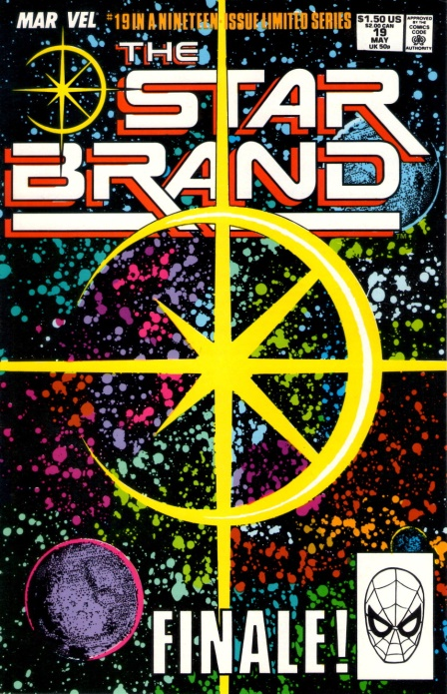

Whether this latter move was to save face by implying the NU was never meant to last or whether it was acknowledgment that all of the NU titles had transformed from their original intention, the implication was quite clear. The writing and editorial staff recognized that what had started as an open organic universe had, by the action of many outside forces, become one of the largest architecturally-structured crossover events attempted. As a result, the *New Universe* ended up having a sprawling internal consistency absent from the larger universes of DC and Marvel. This consistency gave it a feeling more like a set of vignettes in a larger novel rather than a set of titles set in a shared universe. It is not hard to see similarities to the structure, size, mood, and feel found in Katsuhiro Otomo’s *Akira*, which is a huge graphic novel (over 2000 pages) of how metahuman presence in the world triggers global war and subsequent disasters. (Note that this was a common theme of the 1980s and it formed the backbone for another sprawling graphic novel of that time, *The Watchmen.*)

## D.P. 7 (32 Issues & 1 Annual)

Certainly the most stable of the long series runs was *D.P.7*, which was an abbreviation for Displaced Paranormals 7. The brainchild of Mark Gruenwald, who wrote every issue, the series followed the fate of various individuals who were one day normal humans and the next day transformed by the White Event into paranormals.

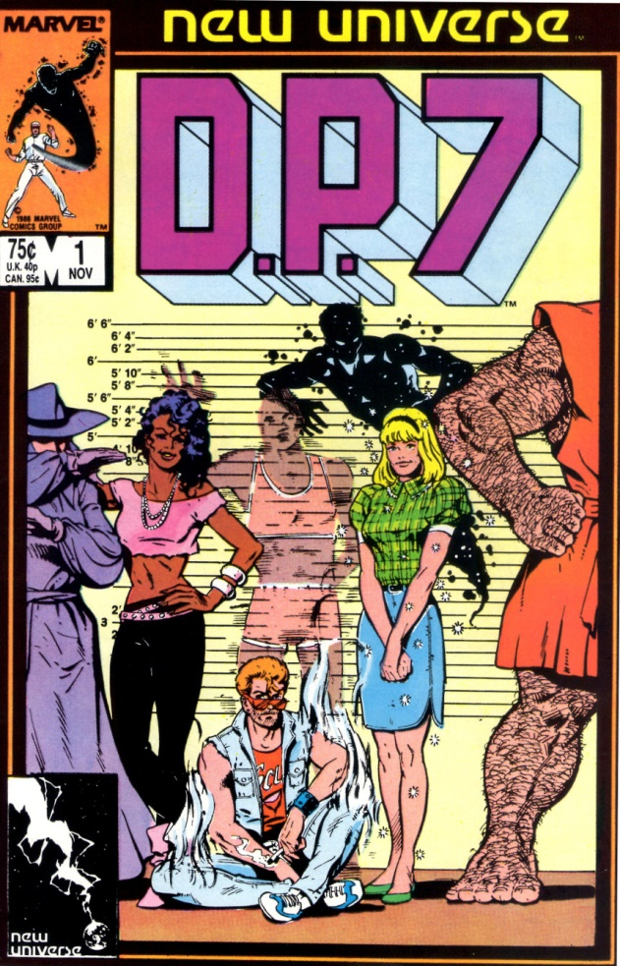

Much of the initial story centers around an institution set in the back woods of Wisconsin with the name of Clinic for Paranormal Research, or the Clinic for short. Each of the original D.P.7 team members has come to the clinic to get ‘treatment’ for their unique paranormal ability. Unbeknownst to them, the Clinic is run by an incredibly powerful paranormal, Philip Nolan Voigt, who had used his equally powerful wealth to assemble a staff of like-minded paranormals to help him develop, mold, and eventually control his own private army of super-powered humans.

Becoming aware of Voigt’s intent, seven of The Clinic’s patients band together and flee. Hounded by the Clinic’s paranormal hunters, the group has many adventures as they try to figure out how they fit together with each other and society as a whole. Eventually, they are recaptured by the Clinic, but manage to seemingly defeat Voigt (issue #12).

Now free of the main villain that kept both the team (and the plot) united, the D.P. 7 team begins to fracture. The Clinic becomes a self-governing paranormal institution and it doesn’t take long before internal politics turns the situation into something more befitting *The Lord of the Flies*, as various loyalties begin to split along demographic lines (African-American paranormals versus teenage paranormals versus…). Before long it is paranormal against paranormal in full-scale donnybrooks.

The situation changes when the destruction of Pittsburgh happens (see *Star Brand & The Pitt* below) and the government begins to recruit paranormals while global tensions rise and war with the Soviet Union seems certain. Once again finding themselves united against a common foe, the paranormals battle official forces

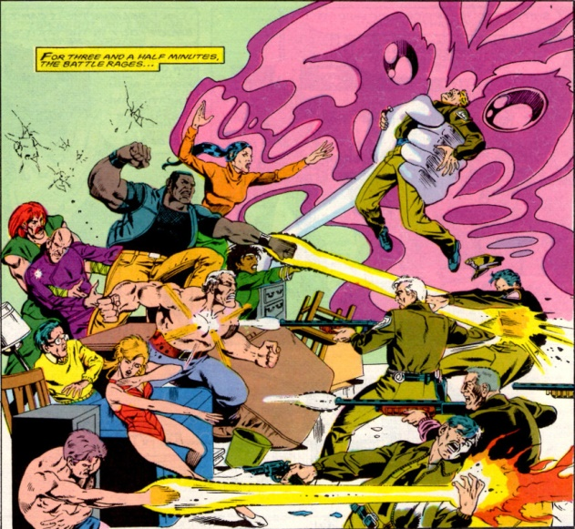

in a desperate attempt to remain on their own. Despite these efforts, many of the women are pressed into service with the CIA and many of the men are conscripted for the Army’s paranormal division.

The series enters into its third and final arc, which shows the consequences of military/government service and the aftermath. In the final couple of issues, a unique paranormal, called the Cure, becomes the focal point. True to his name, the Cure is able to undo the paranormal transformation in anyone who wants to be ‘normal’ again, and the series ends with a bit of closure as many of the most tragic figures go back to being human.

Overall, the series tried from the onset to be ‘real-world’, although it often failed to match Shooter’s original vision of a muted approach to the fantasy/science fiction and the hope that passage of time in the title would match that of our world. The themes explored were mature, with religion, racial tensions, and overall alienation central to the plots.

## Jvstice (32 Issues)

*Jvstice* is the one outsider from the set of NU long-running books. In the beginning, the lead character was a Justice Warrior called Tensen who came from a magical other dimension. Tensen had been exiled to Earth and was seeking an evil wizard by the name of Darquill, who was using the drug trade in our dimension to build up power in order to destroy Tensen’s people.

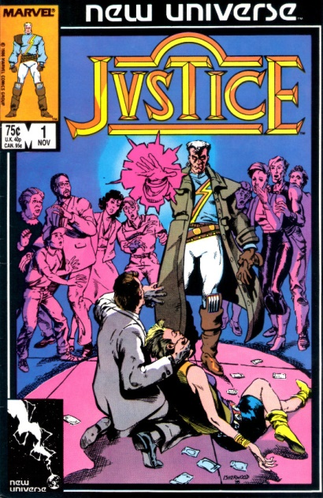

Tensen was very much visualized as a product of the 1980s with balloon pants, futuristic shades, and a *Flock of Seagulls* haircut.

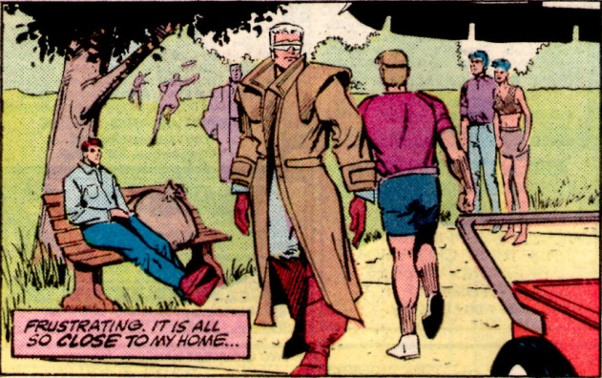

Not only did his clothes seem over the top, the fantasy-based magic theme was completely at odds with the core NU concept. Matters were made worse by the fact that no stable creative staff materialized – 6 writers and 6 artists in the first 14 issues – and by the wandering storyline that continuously waffled in its portrayal of Tensen as victim, sinner, or hero.

Fortunately, the last change happened when Peter David took over the writing chores on issue #15. He retconned the entire series motif in one fell swoop by transforming Tensen Justice Warrior into John Tensen, undercover officer in the Department of Justice. He explained away the magical aspects of the first year by making them a by-product of a psychic struggle between officer Tensen and the drug kingpin Daedalus Darquill, both of whom acquired psionic powers after the White Event.

From this point on, David’s clever plots and skillful dialog changed the entire tenor of *Jvstice*, placing it firmly as the best offering from the NU. A brilliant sample of his approach is captured in the following exchange between Tensen and another character about comic books

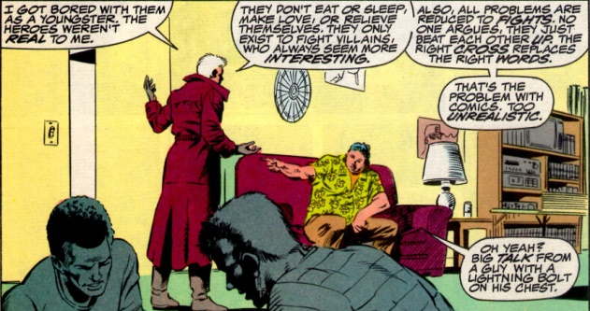

Mindful of his audience, David provides a nice closure for the series in issue #32 with Tensen becoming a just ruler of a paranormal community located on Coney Island, of all places.

## Psi-Force (32 Issues & 1 Annual)

The least interesting of the bigger titles, *Psi-Force* follows the ups and downs of a team of paranormal teenagers from different countries and walks of life.

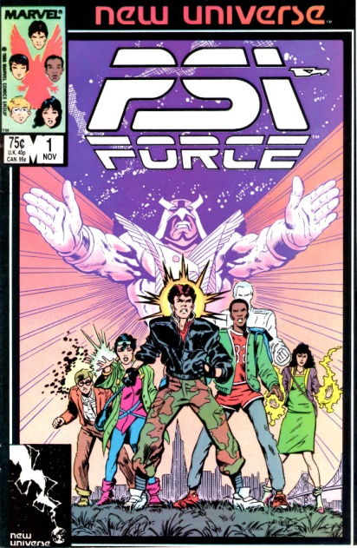

Aside from their paranormal abilities, the only other commonality was that the core team was limited to 5 individuals. The reason for this is that federal agent Emmett Proudhawk, himself a paranormal, brought the team together because of a dream he had,

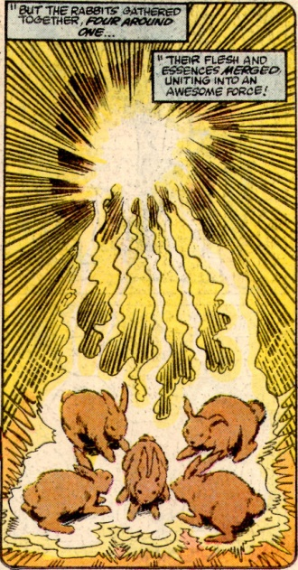

in which he foresaw that the powers of each team member could be merged into an immensely powerful entity called Psi-Hawk.

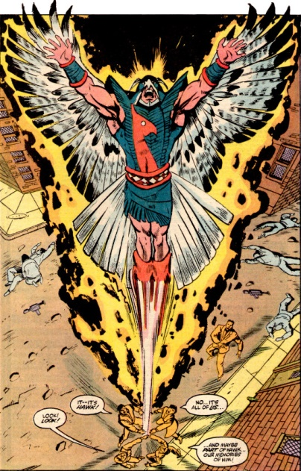

Fewer than 5 members caused Psi-Hawk to be too weak and greater than 5 drove it mad with power. In this way, the *Psi-Force* writer could regulate membership in the team and, presumably, simplify story creation.

The entire run is generally unremarkable from a narrative point of view, with the team implausibly transitioning from scared teenagers to secret agents in a matter of a couple of years. Nonetheless, it has some of the best art of any of the NU titles

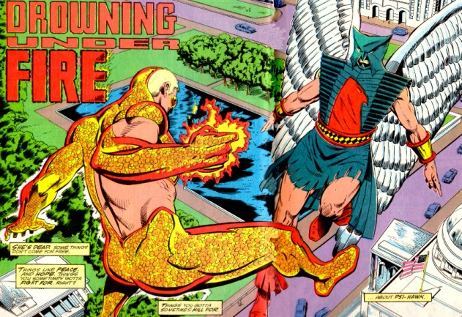

and some of the more interesting, if horrific, deaths for some of its characters.

At the end of its run, the core 5 members have joined into a loose alliance with the Medusa Web, a paranormal mercenary group, before riding into the sunset for some R&R.

## Star Brand (19 Issues & 1 Annual) & The Pitt/Draft/War

The final entry into the NU titles that made it through the whole duration of the imprint is *Star Brand,*

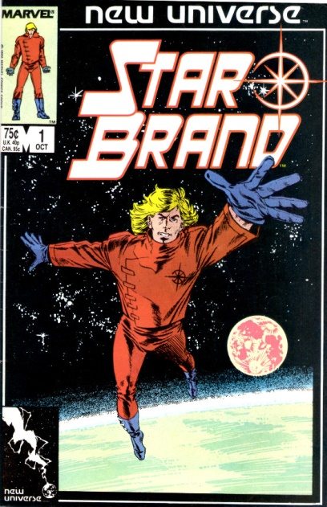

which follows what happens to Ken Connell, a Pittsburgh auto mechanic, when he receives a weapon of surpassing power called the Star Brand from a mysterious old man.

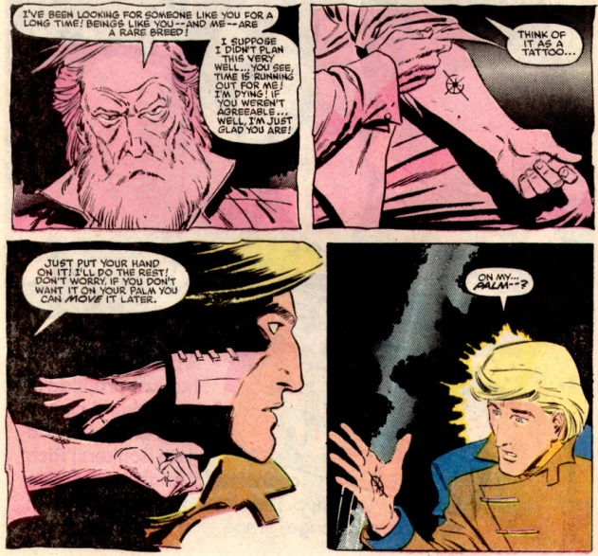

With the Star Brand, Connell is essentially unstoppable, as long as he concentrates and keeps his emotions in check. He soon realizes that having this much power isn’t as easy as it seems and that real world problems can rarely be solved by bludgeoning something or somebody. He begins trying to think rather than punch through the challenges that face him. This theme, which lasts mostly for the first 6-10 issues, is truest to the original NU concept of real-world consequences of having super powers and for good reason – Jim Shooter was the writer for the first 6 issues.

Shooter’s influence is abruptly erased when John Byrne takes over the chief creative role on Star Brand. Byrne’s first action is to have Connell become dejected with the Star Brand and attempt to transfer the brand to a dumbbell. The result is the immediate destruction of the city of Pittsburgh in a ball of light reminiscent to the destruction of Tokyo in *Akira*

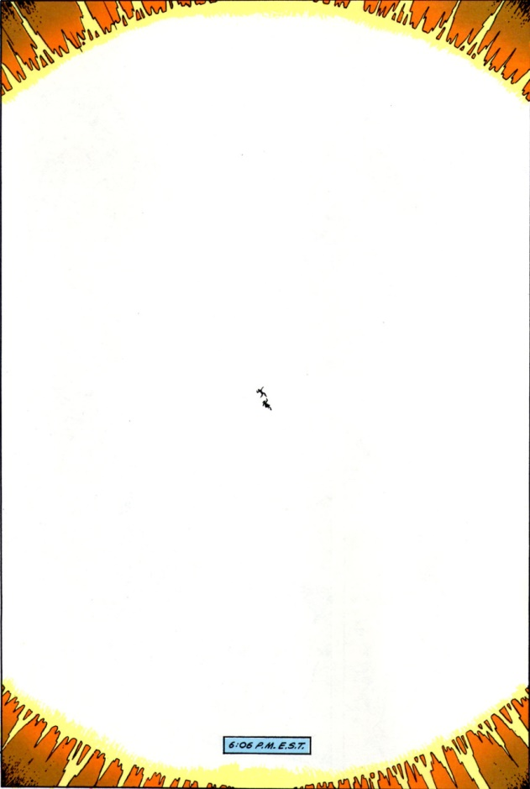

The destruction of Pittsburgh, which is mostly the subject of *The Pitt* one-shot, is the trigger event for the World War III scenario that tied the NU titles together from that point onward. Thinking the destruction had been caused by a nuclear explosion, tensions between the United States and the Soviet Union come to a fever pitch. Both sides recruit and train paranormals for the eventual conflict as covered in *The Draft* one-shot and ongoing issues of *D.P.7* and *Psi-Force*.

The remains of Pittsburgh and surrounding areas, now known as the Pitt,

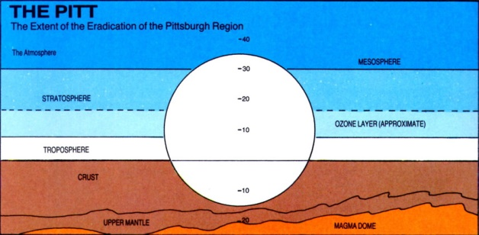

become capable of mutating anyone exposed to the materials and energies at play. The Pitt becomes an additional source of paranormal manifestations, including the transformation of Jenny Swensen into an organic metal woman.

Overcome by guilt, Connell retreats from the world in depression and insanity. His son, who received the power of the Star Brand at his conception, grows at a rapid rate, becoming an adult known as the Star Child (with no apologies or credit given to 2001) within a year of his birth.

The Star Child intervenes, in a messianic fashion, and stops the war between the US and the USSR (as chronicled in *The War* limited series)

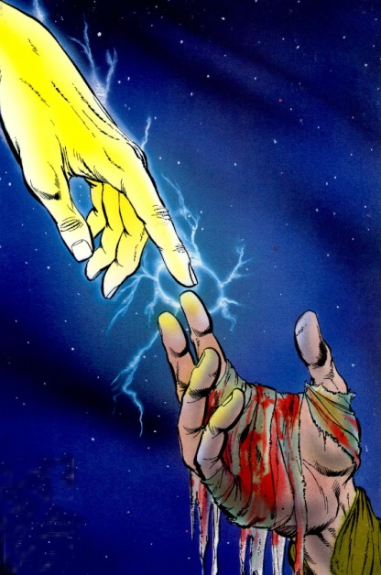

before going on to try to clean up the real source of damage and danger, the Star Brand.

It seems that the White Event, which brought paranormal powers world-wide, was caused when the mysterious old man, now simply called the Old Man, tried to transfer the brand to an asteroid. Inanimate objects are ill-suited for the power of the brand and they detonate with a burst of energy that can mutate and transform every living creature caught in their path. The Star Child also realizes that the Old Man, and Ken, and himself are all three aspects of the same man.

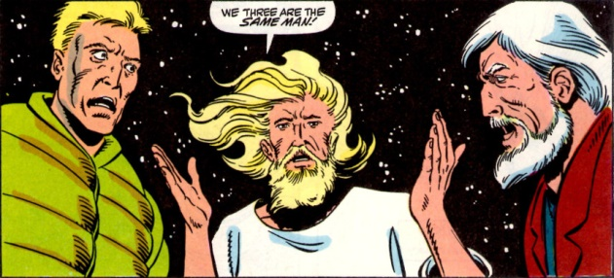

In order to save the universe, the Star Child insists that Ken needs to go back in time to become the Old Man, he needs to go back in time to become Ken, and, presumably, the Old Man also goes back in time to become the infant Star Child. Of course, this makes absolutely no sense, and Byrne’s job of explaining this is [badly flawed as almost all time-travel stories are](http://aboutcomics.blogwyrm.com/?p=47).

It is ironic that the one title in the New Universe imprint which started out most faithfully following the NU concept that paranormal abilities come with real-world consequences should end with, arguably, one of the biggest *deus ex machina* moments in all of comics history.

## Plasma Frequency

This month’s installment focuses on that aspect of plasma dynamics that is strongly analogous with mechanical vibration: plasma oscillations. Plasma oscillations were first predicted by Paul Langmuir in the 1920s and later observed in vacuum tubes of the day.

These oscillations manifest themselves as cooperative movements in a plasma’s charge distribution that behave sinusoidally. The harmonic nature of these deviations from perfect neutrality is basically due to an electrostatic restoring force that, for small amplitudes around equilibrium, is well approximated as quadratic. Thus the electrostatic restoring force gives rise to a harmonic potential. The analog with mechanical oscillations is completed with the identification of the electron and ion centers-of-mass velocities with the macroscopic kinetic energy of the mass on the spring. Plasma oscillations provide strong support for the basic assumptions of electromagnetic theory and a nice example of how mechanics and electrodynamics meet in a physically relevant situation.

The aim here is to derive the formulae ffor the plasma oscillations for two related cases and then to interpret the results in terms of mechanical vibration with the familiar spring mass system.

Imagine that there is a slab of plasma of length $$\ell_0$$, with cross-sectional area $$A$$ and an initial number density of ions and electrons of $$n_0$$. Since the condition of quasi-neutrality is in effect, there is no net electric field in any part of the plasma. Now imagine that due to an outside agency, all of the electrons are displaced by the very small amount of $$\Delta x$$ to the left, leaving a net positive charge on the right and net negative charge on the left, with the thickness of these two ‘non-neutral’ regions is $$\Delta x$$.

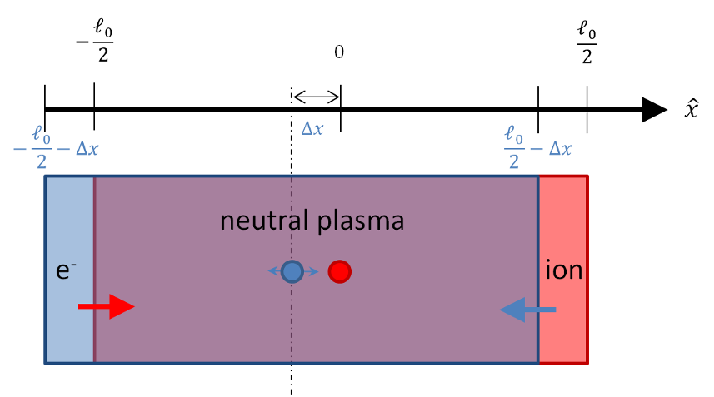

How does the plasma respond to this out of equilibrium condition? The first approximation one can make is that the electrons are free to move but the ions are fixed in space. This corresponds to the physical approximation that the ions have an infinite mass – an approximation that is well supported by the ~2000 – 1 ratio between the mass of a proton and that of an electron.

The electrons will feel a strong restoring force (red arrow) and they will move accordingly. Since the ions are fixed, they will feel an equal but opposite restoring force (blue arrow) but they will not be able to respond.

The electric field that the electrons will feel, which is most easily obtained from Gauss’s law, results between the strips of positive and negative charge in an exactly analogous fashion as to the textbook problem on parallel plate capacitors. The density of ions in the red region is $$n_0$$ and the volume is $$A \Delta x$$. Since $$\Delta x$$ is small compared to the other dimensions, the electric field is closely approximated as being entirely in the $$x$$-direction and the total flux through a Gaussian surface whose boundaries coincide with the ion region is due strictly to the left and right faces. The right face flux is exactly zero since the flux from the electrons exactly cancels the flux from the ions. The left face flux, which is equal to the total flux, is then

\[ \Phi_E = E A \; , \]

which is proportional to the total charge enclosed

\[ \Phi_E = \frac{e n_0 A \Delta x}{\epsilon_0} \; .\]

Equating gives

\[ E= \frac{e n_0 }{\epsilon_0 } \Delta x \; ,\]

which is the usual result for the field between a parallel plate capacitor ($$n_0 \Delta x$$ is the surface charge density).

As the electrons were all displaced uniformly and are experiencing a uniform force, they will move together as a unit, that is to say cooperatively. The mass of the unit is simply the mass density $$m_e n_0$$ times the volume consumed $$V = A \ell_0$$. The center of mass of the slab is at $$\ell/2- \Delta x$$ with the corresponding acceleration $$\Delta {\ddot x}$$. The force on the slab is

\[ F = q_{tot} E = -e n_0 V \frac{e n_0}{ \epsilon_0} \Delta x\]

and the equation of motion of the entire slab is given by:

\[ m_e n_0 V \frac{d^2}{dt^2} \Delta x = -e n_0 V \frac{e n_0} {\epsilon_0} \Delta x \; .\]

Dividing out the common factors gives

\[ \frac{d^2}{dt^2} \Delta x = -\frac{e^2 n_0}{m_e \epsilon_0} \Delta x \; .\]

From this equation we would conclude that, for small displacements, the electron slab would oscillate at the angular frequency

\[ \omega_{pe} = \sqrt{ \frac{e^2 n_0}{m_e \epsilon_0} } \; , \]

which is called the electron plasma frequency (note it is really an angular frequency).

Relaxing the assumption that the ions don’t move makes the analysis somewhat more complicated but only changes the result in a small but crucial way. The location of both electron and ion centers-of-mass now matter and must be tracked separately. The picture of their motion is now

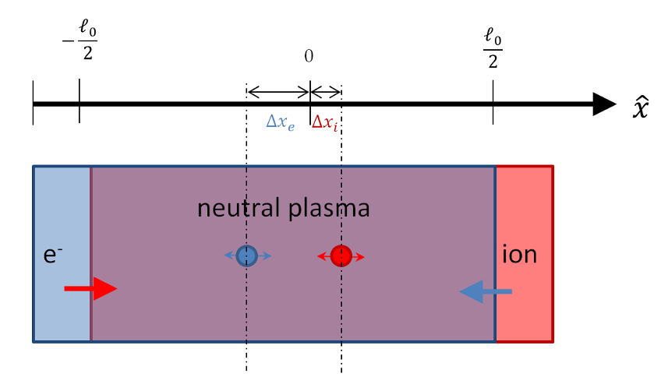

Since both species are free to move, the thickness of the exposed electron or ion regions (red and blue) is not determined solely by the movement of their respective centers-of-mass (the ion region pictured above is much larger than $$\Delta x_i$$) . The total thickness of the exposed regions depends on the relative motion between both centers-of-mass

\[ t = \Delta x_i - \Delta x_e \; .\]

An initial analysis may suggest that there are 8 separate cases: positive or negative variations for each species (2x2) as well as whether the ions are more displaced versus the electrons. In fact, there are only two cases based on whether $$t$$ is positive (ion strip is on the right) or whether $$t$$ is negative (ion strip is to the left). The following table shows the 8 variations for $$\ell = 1$$.

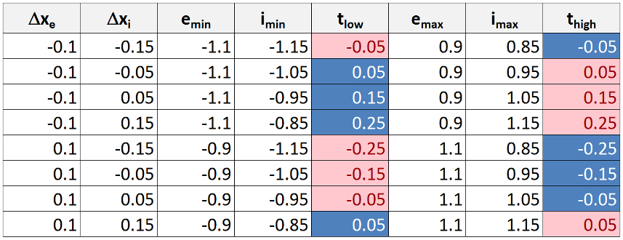

The parameters with the ‘min’ designate the leftmost extent of the electron slab ($$e_{min}$$) and the ion slab ($$i_{min}$$). The parameter $$t_{low} = i_{min} - e_{min}$$. A negative value, such as in case 1, means that the ion slab has shifted more to the left than the electrons and that the exposed ion region (red) is now on the left while the exposed electron region (blue) is now on the right. A positive value of $$t_{low}$$ means the converse. The corresponding parameters at the rightmost side are defined in an analogous fashion. The color coding assists in visualizing which species is in which location. Note that the entire table can be summarized by $$\Delta x_i - \Delta x_e$$, whose magnitude and sign match $$t_{low}$$ and $$t_{high}$$. Also note that the displacements in the table are purely geometric and that the actual dynamic displacements would not shift the total center-of-mass since the only forces in the problem are internal.

The electric field in between the two uncovered charge regions can also be obtained by Gauss’s law, but it is instructive to use the expression for the electric field due to a sheet of charge that and superposition. The electric field due to the ions will have a magnitude of

\[ E_i = \frac{e n0}{2 \epsilon_0} \left(\Delta x_i - \Delta x_e \right) \]

using the standard result from elementary E&M.

Likewise the electric field due to the electrons will also have the same magnitude $$E_e = E_i$$. Their directions will be the same in the region between them (the neutral plasma) and opposite outside, so that a non-zero field with magnitude $$2 E_i$$ will result only in the middle region. The direction of the field depends on which one is on the right versus the left but it doesn’t matter for the sake of the dynamical analysis.

The equation of motion for each slab is then given by

\[ m_i \frac{d^2}{dt^2} \Delta x_i = -\frac{e^2 n_0}{\epsilon_0} \left(\Delta x_i - \Delta x_e\right) \]

and

\[ m_e \frac{d^2}{dt^2} \Delta x_e = \frac{e^2 n_0}{\epsilon_0} \left(\Delta x_i - \Delta x_e\right) \; . \]

Combining these two equations gives

\[ \frac{d^2}{dt^2} \left( \Delta x_i - \Delta x_e \right) = -\frac{e^2 n_0}{\epsilon_0}\left(\frac{1}{m_e} + \frac{1}{m_i} \right) \left(\Delta x_i - \Delta x_e\right) \]

from which we conclude that the frequency is now

\[ \omega_p^2 = \frac{e^2 n_0}{\epsilon_0}\left(\frac{1}{m_e} + \frac{1}{m_i} \right) = \frac{e^2 n_0}{\epsilon_0 m_e} + \frac{e^2 n_0}{\epsilon_0 m_i} \equiv \omega_{pe}^2 + \omega_{pi}^2 \; .\]

The above analysis has a direct analog in a mechanical system of two unequal masses $$m_1$$ and $$M_2$$ connected by a spring of spring constant $$k$$ and equilibrium length $$\ell_0$$.

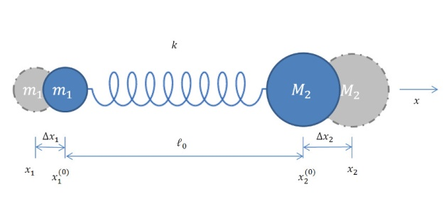

Defining the deviations of each mass from the equilibrium positions as

\[ \Delta x_1 = x_1 - x_1^{(0)} \]

and

\[ \Delta x_2 = x_2 - x_2^{(0)} \]

the distance between them takes the form

\[ x_2 - x_1 = x_2^{(0)} + \Delta x_2 - x_1^{(0)} - \Delta x_1 \equiv \ell \; .\]

Combining these two definitions gives

\[ x_2 - x_1 = \ell - \ell_0 = \Delta x_2 - \Delta x_1 + \ell_0 \]

from which the potential follows as

\[ V = \frac{1}{2} k (\ell - \ell_0)^2 = \frac{1}{2} k (\Delta x_2 - \Delta x_1)^2 \; .\]

The Lagrangian takes the form

\[ L = \frac{1}{2} m_1 \Delta \dot x_1^2 + \frac{1}{2} M_2 \Delta \dot x_2^2 - \frac{1}{2} k (\Delta x_2 - \Delta x_1)^2 \; , \]

with the equations of motion becoming

\[ \frac{d}{dt} \frac{\partial L}{\partial \dot x_1} - \frac{\partial L}{\partial x_1} = m_1 \Delta \ddot x_1 + k(\Delta x_2 - \Delta x_1 ) = 0 \]

and

\[ \frac{d}{dt} \frac{\partial L}{\partial \dot x_2} - \frac{\partial L}{\partial x_2} = M_2 \Delta \ddot x_2 - k(\Delta x_2 - \Delta x_1 ) = 0 \]

These equations combine nicely into one expression for the dynamics of the change in the separation between the two masses

\[ \delta \ddot \ell = -\left( \frac{k}{m_1} + \frac{k}{M_2} \right) \delta \ell \; , \]

which immediately tells us that the frequency of the oscillations is given by

\[ \omega^2 = k \left(\frac{1}{m_1} + \frac{1}{M_2} \right) = \omega_1^2 + \omega_2^2 \; .\]

In the limit as $$ M_2 \rightarrow \infty $$, the equation of motion simplifies to

\[ \delta \Delta \ddot x_1 + \frac{k}{m_1} \Delta x_1 = 0 \; ,\]

with frequency of

\[ \omega^2 = \frac{k}{m_1} = \omega_1^2 \; .\]

Thus there is a perfect analogy between the two pictures and the cooperative motion of the electrons and ions within the plasma can be interpreted in strictly mechanical terms.